*Florida International University*

*School of Computing and Information Sciences*

CIS 4911 - Senior Capstone Project

Software Engineering Focus

Feature Document

User Story # **768 Draw with the Kinect**

**Team Member:**

Alexander Karpis

**Product Owner(s)**:

Francisco Ortega

**Mentor(s)**:

Francisco Ortega

**Instructor**: Masoud Sadjadi

**User Story**

* As a User I would like to draw lines using the Kinect device so I can draw on the canvas.

**Acceptance Criteria**

1. User must be able to draw lines using the Kinect device.
2. User interaction while drawing must be smooth and simple.

**Use Case** # **– Draw with the Kinect**

The users will be able to Paint Lines using the Kinect.

Actors: **Inherited from Paint use case.**

Entry Condition:

This use case start when:

* **Inherited from the Paint use case**
* The user has notified the system they are using the Kinect.

Flow of events:

1. The user requests the Kinect be activated.

2. The system activates the Kinect and notifies the user.

3. The user takes the action for painting lines in the paint program with the Kinect.

4. The system paints when the user performs the paint action.

Exit Condition:

**Inherited from the Paint use case.**

**Use Case Diagram**

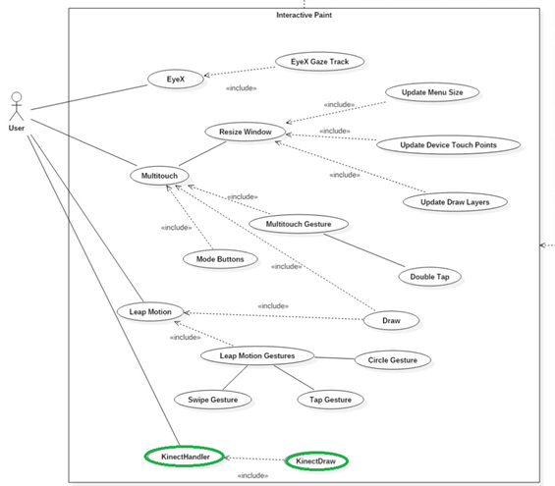

**Sequence Diagram**

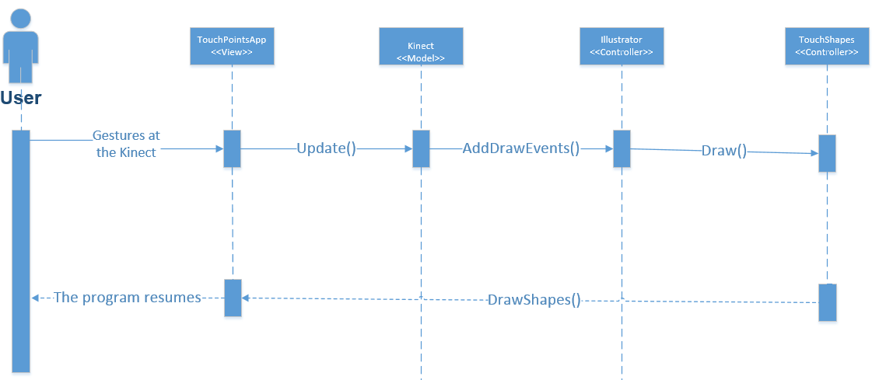

**Class Diagram**

|  |
| --- |
|  |

**Unit Test**

Sunny Day Tests

Test Case: Draw with Kinect

Test Purpose: Ensure that user can draw with the Kinect…

Test Setup:

⦁Setup Kinect and run program.

Test Output:

Drawn according to motions with the Kinect.

Expected Output:

After closing one’s hands with the Kinect, the screen should draw correctly.

**Integration Test**

After adjusting the frame rates for the Kinect, the Kinect connects well with the current program.

**Visual User Guide**

The user begins with open hand which produces a green circle for hand location:

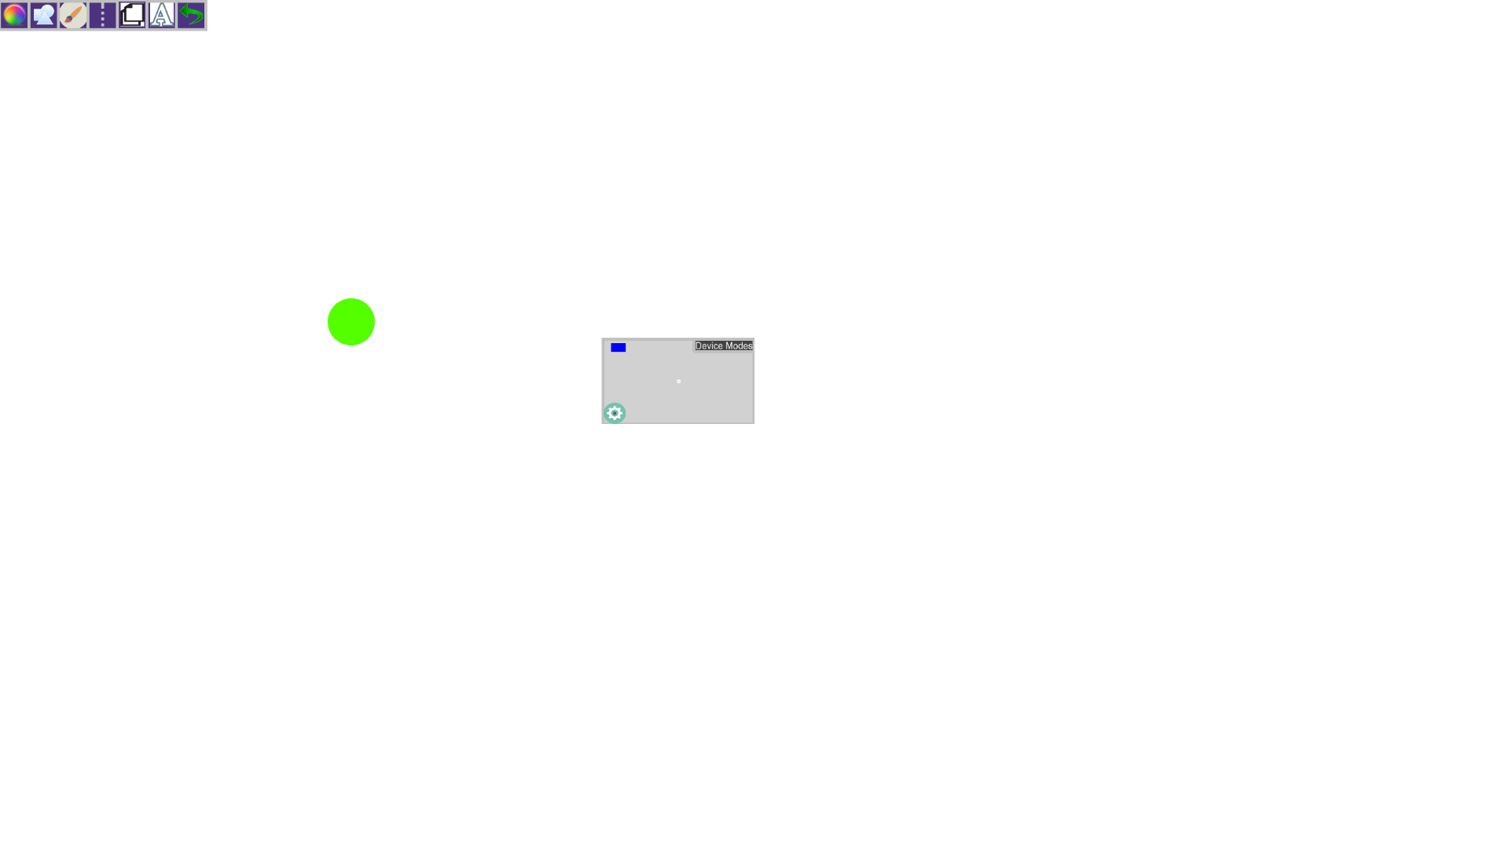

Then the user closes their hand to paint and reopens it when finished:

